# Research and Innovation in Forensic Science: Achieving Quality Matters Course Certification

Dr. Amy J. Heston, Professor of Inorganic Chemistry, Walsh University [aheston@walsh.edu](mailto:aheston@walsh.edu)

# Highlights from Multiyear Improvements Leading to QM Certification

Highlights of Improvements of Walsh 1st Forensic Science Course (NS 114)

* **Weekly quizzes** to reinforce key concepts. (**case study** quizzes, too)
* **Reflections** to promote self-expression and critical analysis
* **Improved rubrics** for discussions, reflections, and case study
* **Increased** learner-learner and learner-instructor **interaction**
* **Enhanced social presence** through discussion forums and lesson videos

# Evidence of Student Success

* **Increase variety**: added videos to demonstrate forensic applications
* Lessons with **smaller stakes**: discussion, quiz, reflection each week
* Discussion forum: increased **sense of community** in class
* Feedback within term: students **loved course design** & content!
* Increase in course **grades** each week
* Course evaluations stated **course design was critical to success**
* **Overall grades** increase significantly compared to previous years
* Strategies work for **various disciplines**

*Personally, QM helped me become a* ***more impactful educator***

# Quality Assurance Evidence & Artifacts

* 2024, Walsh’s 1st QM Publication, *J of Forensic Sci Ed* 2024, 6(2).
* 2023-2025, Honors advisor for Walsh’s 1st UG student: QM implementation

Broader Impact: **Quality Assurance Lasagna** (Gemini-created image)

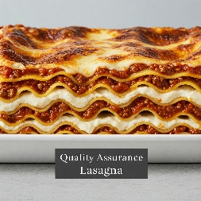

Layers of Impact:

Quality Course Design/ Student Success in CLOs/ Course Assessment/ Program Assessment/ Accreditation/ Institutional Effectiveness/ Institutional Strategic Goals/ University Mission